FIRST, go to the website http://tinyurl.com/nyt200essay
NAME: New York Times 200 Prompts Essay Mr. G
SECOND, read over the prompts. Choose 3 prompts that sound like they would be interesting to read and write about.
The Prompts are organized by topic:
Education- Prompts 1-39
Technology and Social Media- Prompts 40-64
Arts and Media: TV, Music, Video Games, and Literature- Prompts 65-89
Gender Issues- Prompts 90-104
Sports and Athletics- Prompts 105-120
Politics and the Legal System- Prompts 121-139
Parenting and Childhood-Prompts 140-155
Health and Nutrition- Prompts 156-165
Personal Character and Morality Questions- Prompt 166-185
Science- Prompts 186-191
Other Questions- Prompts 192-200
- Write the 3 Prompts you would be interested looking further into:
  - ____________________________________________________________________
  - ____________________________________________________________________
  - ____________________________________________________________________

THIRD, read the article for each prompts. Write a brief explanation of what each article is about:

Article Title: ________________________________________________________________________________
Give a brief explanation of the contents of the article. Does the article take a particular position? Do you agree or disagree with the article? Why?
______________________________________________________________________________________________
______________________________________________________________________________________________
______________________________________________________________________________________________
______________________________________________________________________________________________
____________________________________________________________________________________________________________________________________________________________________________________________

Article Title: ________________________________________________________________________________
Give a brief explanation of the contents of the article. Does the article take a particular position? Do you agree or disagree with the article? Why?
______________________________________________________________________________________________
______________________________________________________________________________________________
______________________________________________________________________________________________
______________________________________________________________________________________________
____________________________________________________________________________________________________________________________________________________________________________________________

Article Title: ________________________________________________________________________________
Give a brief explanation of the contents of the article. Does the article take a particular position? Do you agree or disagree with the article? Why?
______________________________________________________________________________________________
______________________________________________________________________________________________
______________________________________________________________________________________________
______________________________________________________________________________________________
____________________________________________________________________________________________________________________________________________________________________________________________

FOURTH, choose ONE prompt out of the three. Write the prompt below.
My Persuasive essay prompt:
_____________________________________________________________________________________

FIFTH (and final), write a quick thesis for your prompt.
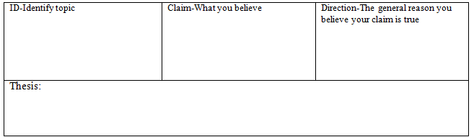
Great work! You’re well on your way to writing ANOTHER great essay!

